

**8051 Microcontroller Based Automatic**

**Railway Gate Control**

***Suraj Tripathy (B215059)***

***Syed Ishrar Ali (B215061)***

***Abhinna Pradhan(B215003)***

*UG Students*

*Department of Electronics and Telecommunication Engineering*

*International Institute of Information technology Bhubaneswar*



Under the guidance of

***Venkata Sridhar T***

Assistant Professor

Department of Electronics and Telecommunication Engineering

International Institute of Information technology Bhubaneswar

**Abstract**

As we are aware that the number of accidents at railway crossing has been increasing lately, more precautionary measures are being undertaken. Accidents take place either due to the absence of crossing gates, or due to impatience and carelessness of pedestrians. There are many places where the railroad crossings are open, without any gates. This becomes an open threat to the people or vehicles who wish to cross the railroad. Whereas, there are places where the crossing gates at railroad is being controlled and managed by a guard. In such cases, threat may arise due to carelessness of the guard. So, our project aims at automating this process. Automatic Railway Gate Control is managed and controlled by microcontroller 8051 and is more reliable since there is no human intervention in the process. Our model, most primarily, is different from others in terms of the programming method and considering various possibilities that the actually railroad crossing system encounters. We have programmed 8051 using assembly language program (.asm). Infrared (IR) sensors are used which senses the presence of train and conveys the information to 8051. 8051 is programmed accordingly to open or close the gate whenever required. Also, the steps for creating hex file from the program are elaborated. Keil uvision5 is being used to create the hex file.

**Diagrammatic Working**

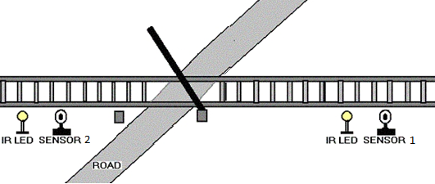

*The gate is opened when there is no train approaching*

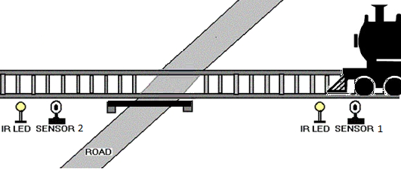

*The gate is closed down automatically when a train approaches so that no vehicles can cross the railway track*

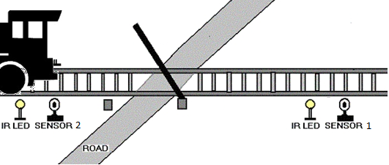

*After the train leaves,the gate is automatically opened for vehicles to cross the tarck*

**Introduction**

This system is designed to manage the control system of railway gate using the microcontroller. The main purpose of this paper is to propose an idea to make the process automated so that the probability of accidents reduces drastically. This system is designed using 8051 microcontroller to avoid railway accidents happening at railroad crossings. As a train approaches the railway crossing from either side, the sensors placed at a certain distance from the gate detects the approaching train and informs the microcontroller about it. This signal is used to trigger the microcontroller for opening or closing of gates. The abstraction of this system is to provide the advanced control system available to everywhere.

**PROJECT OBJECTIVE**

This system is to manage the control system of railway gate using the microcontroller. The main purpose of this system is about railway gate control system and level crossing between railroad and highway for decreasing railroad-related accident and increasing safety. In addition, it also provides safety to road users by reducing the accidents that usually occur due to carelessness of road users and errors made by the gatekeepers. Railways are the preferred cheapest mode of transportation over all the other means. Also, it is evident from the experimental results that accidents at railroad crossings with the gate control are far less than those crossings that are devoid of gates.

**THEORY**

The main idea of this model is to sense the presence of locomotive and take necessary actions to open or close the gates. IR sensors are used to sense the presence of locomotive and these signals are being sent to microcontroller 8051. 8051 is efficiently programmed to take proper actions.

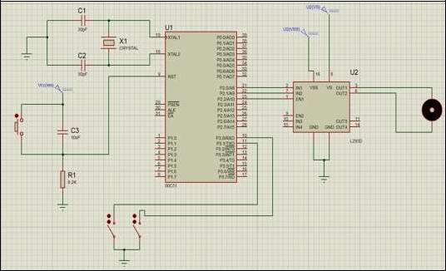



*Interfacing of IC L293D with 8051*

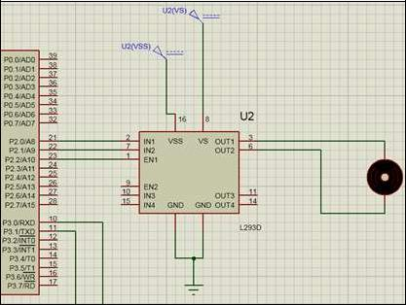

LM293D is a motor driver IC which is interfaced to the 8051 IC. The DC Motor is connected to the first pair of drivers and it is enabled by connecting EN1 to logic HIGH (5V). VSS pin is used to provide logic voltage to L293D. Here 8051 microcontroller, which works at 5v is used to control L293D, hence the logic voltage is 5. The motor supply is given to Vs pin of the L293D .The function of IN1 and IN2 pins is show below –

Function of IN1 and IN2 pins

|  |  |  |
| --- | --- | --- |
| *IN1 / P2.0* | *IN2 / P2.1* | *Motor Status* |
| *Low* | *Low* | *Stops* |
| *Low* | *High* | *Clockwise* |
| *High* | *Low* | *Anti - Clockwise* |
| *High* | *High* | *Stops* |

The materials and components that are used in automatic railway gate control system is mentioned below. As in normal control design, system can be roughly divided as input, output and processing sections. The main components of system are:

a) 8051 Microcontroller

b) Motor Driver IC L293D

c) Infrared Sensor (IR LED )

d) Resistors & Capacitors

**CONCLUSION**

Automatic gate control system offer an effective way to reduce the occurrence of railway accidents. This system can contribute a lot of benefit either to the road users or to the railway management. Since the design iscompletely automated it can be used in remote villages where no station master or line man is present. Railway sensors are placed at two sides of gate. It is used to sense the arrival and departure of the train. This system uses the DC motor to open and close the gates automatically when it is rotated clockwise or anticlockwise direction. Now a day’s automatic system occupies each and every sector of applications as it is reliable and accurate.We demonstrate that it is possible to improve the overall safety of the railway system in India. The proposed system provide the means for real time inspection, review and data collection for the purpose of maintenance on the movable and fixed facilities for the guarantee of operation safety and maintenance efficiency as well as the safety appraisal decision-making system based on the share of safety data